**PROCESS DOCUMENT – PHASE 2**

**Contents**

**1.** Review of Application Fee Disclosure

**2.** Upload FromFree Id into Cadence

**3.** Employment Verification Using Worknumber

**4.** County Map Download

**5.** Round Robin Assignment of Processors

**6.** Dispatcher Process

**7.** Compliance Report Process

**8.** Standard Flood Determination

**REVIEW APPLICATION FEE DISCLOSURE DOCUMENT**

**STEP 1:**

Login to Cadence application using valid user credentials

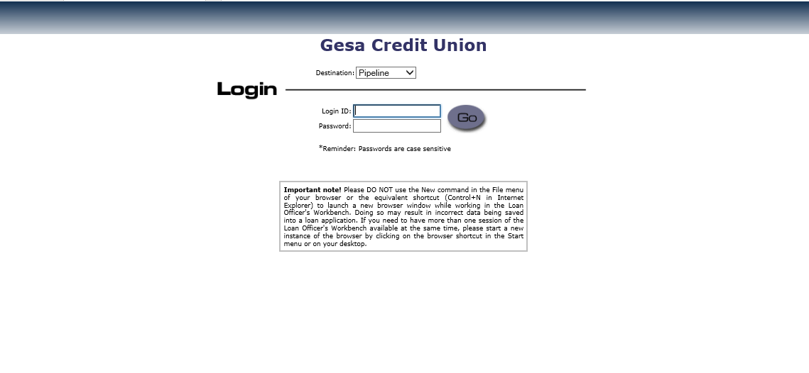

**STEP 2:**

Loan Ids are passed one by one from the orchestrator queue and searched for in cadence.

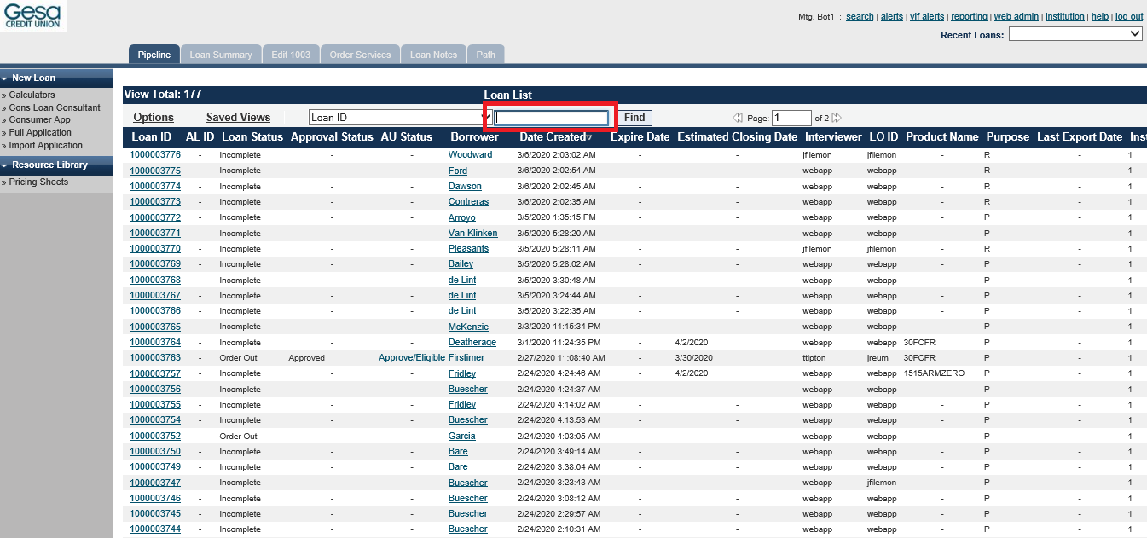

**STEP 3:**

Once the Loan summary page is loaded, the bot navigates to Edit 1003 page and selects the borrower tab and extracts the borrower SSN.

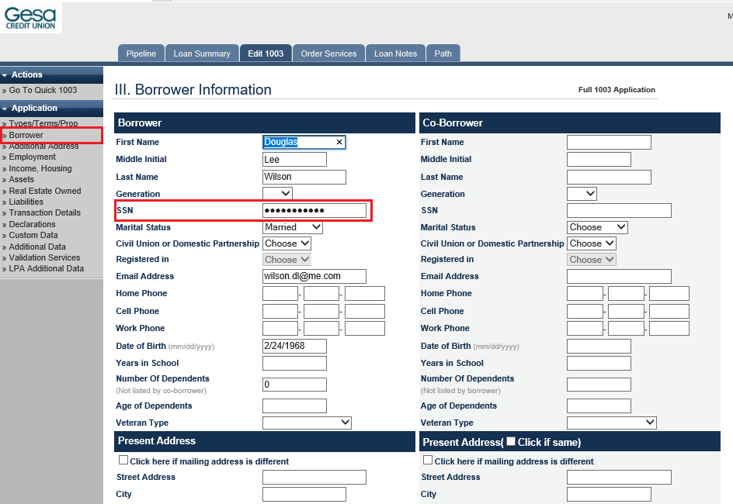

**STEP 4:**

The bot now navigates to the virtual loan folder (VLF) of that applicant from the loan summary page.

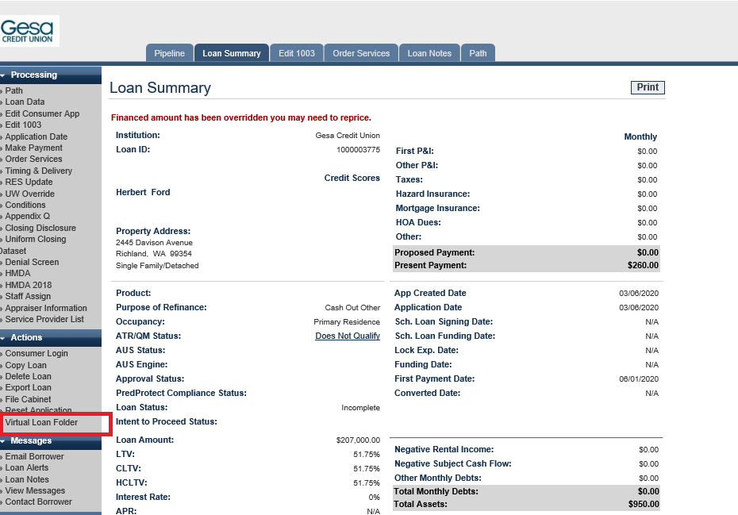

**STEP 5:**

In the virtual loan folder, the bot searches for the existence of “Application Fee Disclosure” document by typing in the search bar.

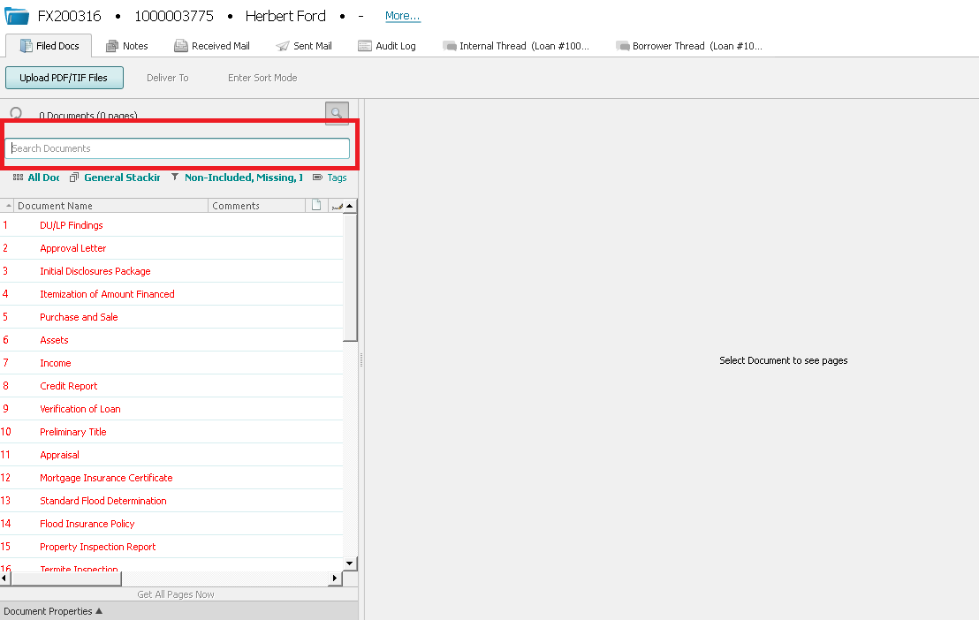

**STEP 6:**

If application fee disclosure file exists, the bot clicks save document as pdf and saves the file into the desired folder.

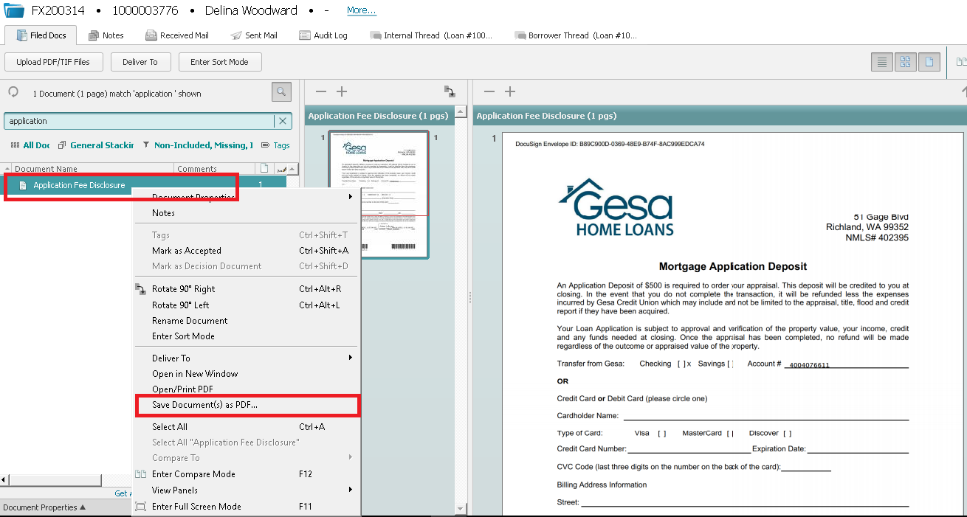

**STEP 7:**

The saved application fee disclosure file is now passed as the input to Abby flexicapture OCR to extract the necessary details.

To begin with, the bot checks for the presence of account number in the Pdf. If the account number exists, it then checks if the checking option is ticked under transfer from Gesa.

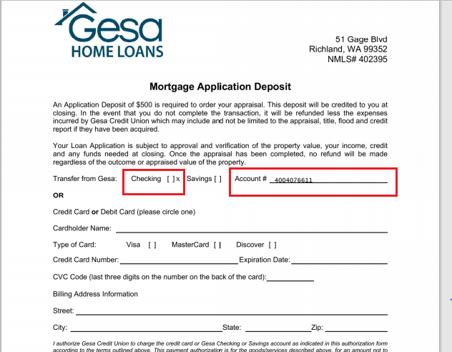

**STEP 8:**

Since account number field is filled, the bot now logs into DNA using valid credentials.

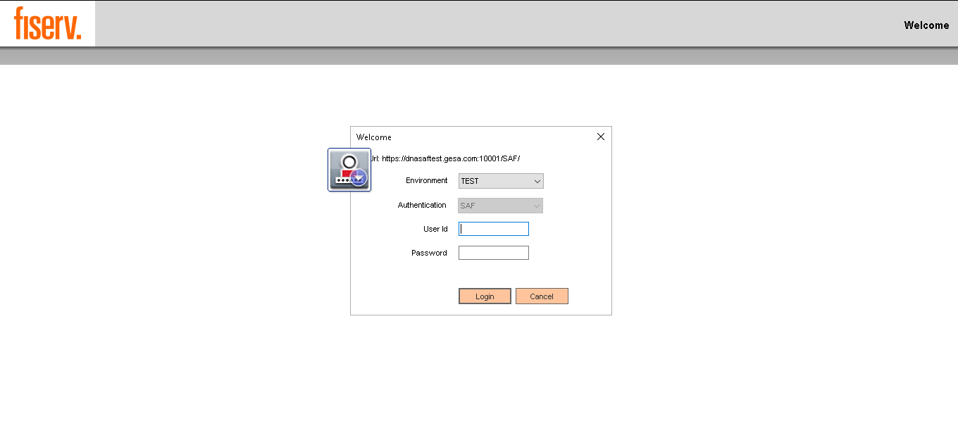

**STEP 9:**

Click on Quick Inquiries button from the menu bar and navigate to smart search page and enter the SSN that needs to be checked for account balance.

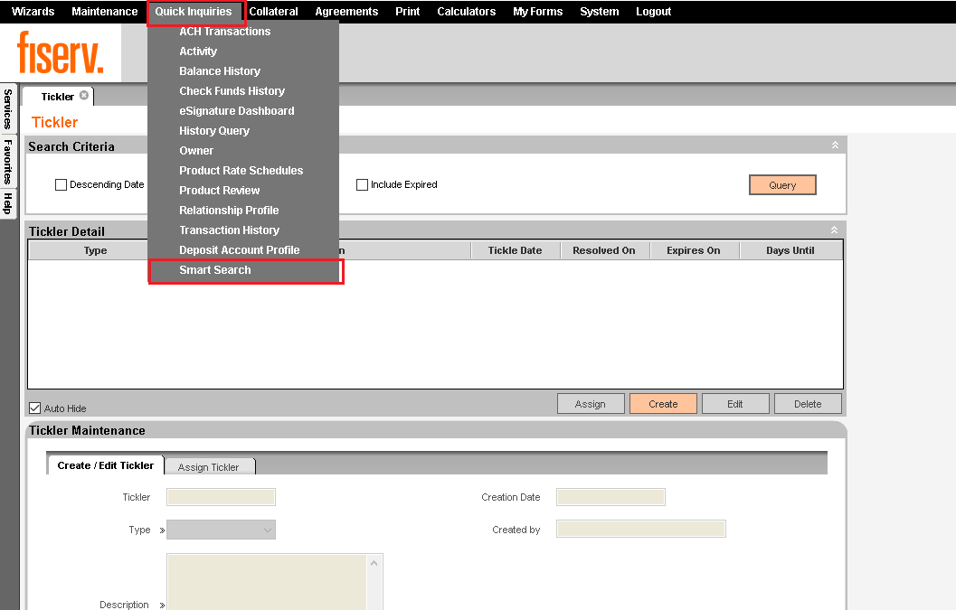

**STEP 10:**

In the smart search results, if an account is found for that particular SSN, then the bot selects the accounts tab of that user and checks if the account collected balance is greater than $500. If no user is found on DNA for that SSN, then a business exception is throw and the process continues with the next transaction.

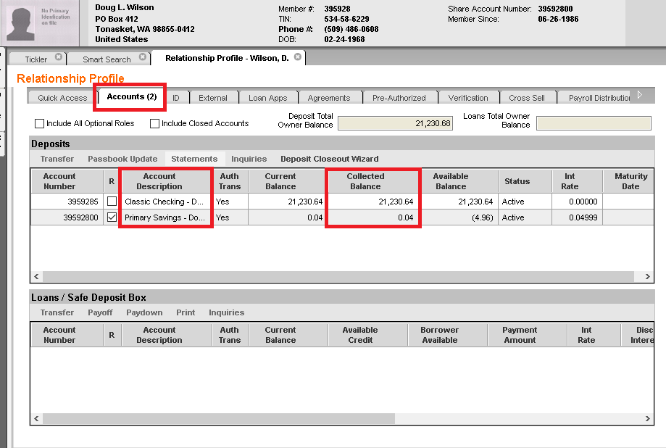

**STEP 11:**

If the account collected balance is greater than $500, then it logs the same in the SQL database and moves on to the next transaction.

**STEP 12:**

In the application fee disclosure file if credit card number is present instead of account number, then the bot checks for the presence of CVV and expiry date. If they present, then it logs the same in the SQL database and continues with the next transaction.

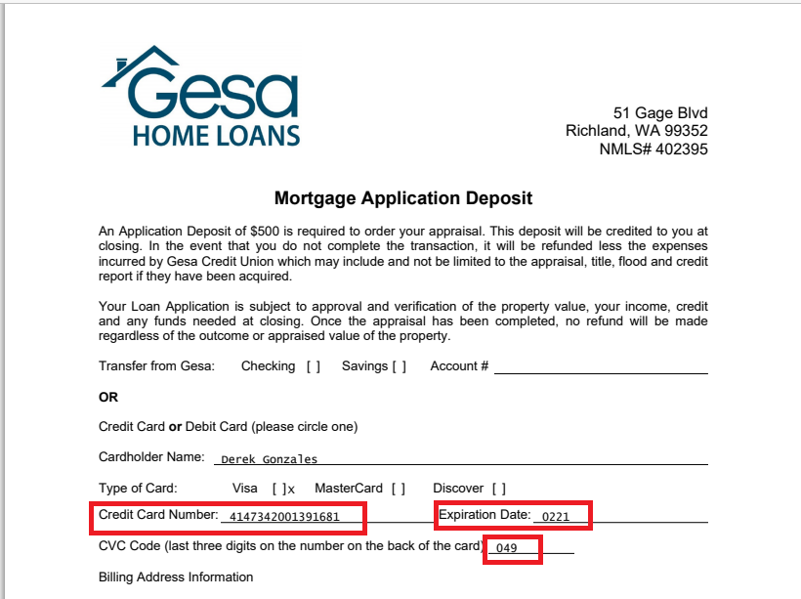

**Upload Formfree Id into Cadence**

**STEP 1:**

Login to cadence application using valid user credentials



**STEP 2:**

Loan Ids are passed one by one from the orchestrator queue and searched for in cadence.

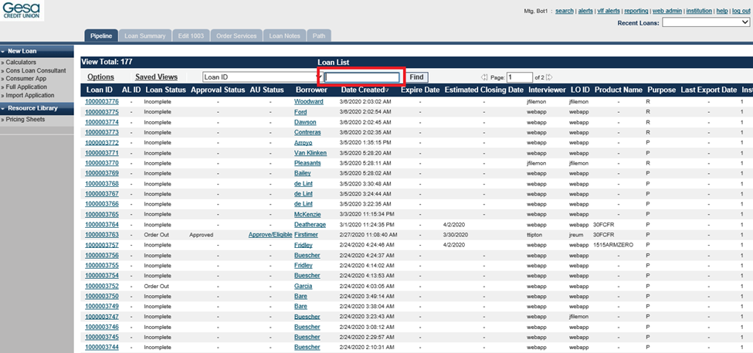

**STEP 3:**

Once the loan summary page is loaded, the bot navigates to the virtual loan folder application



**STEP 4:**

In the virtual loan folder, the bot opens “Assets” folder and checks if it contains any files. If files are present, then it downloads them by clicking on “save document as pdf”. If no asset files are found, then the bot skips that particular transaction

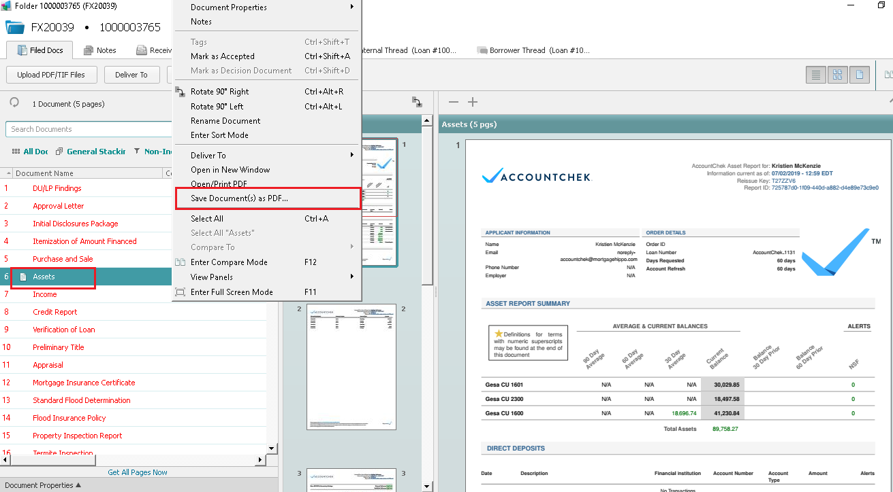

**STEP 5:**

Regular expression is applied to the downloaded pdfs and “report Id” and “report for” value is extracted from it

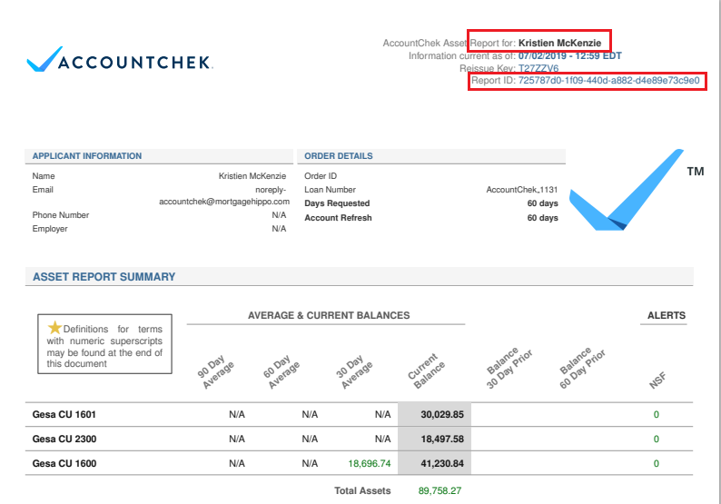

**STEP 6:**

In the cadence application, the bot now navigates to edit 1003 page and clicks on validation services from the side menu

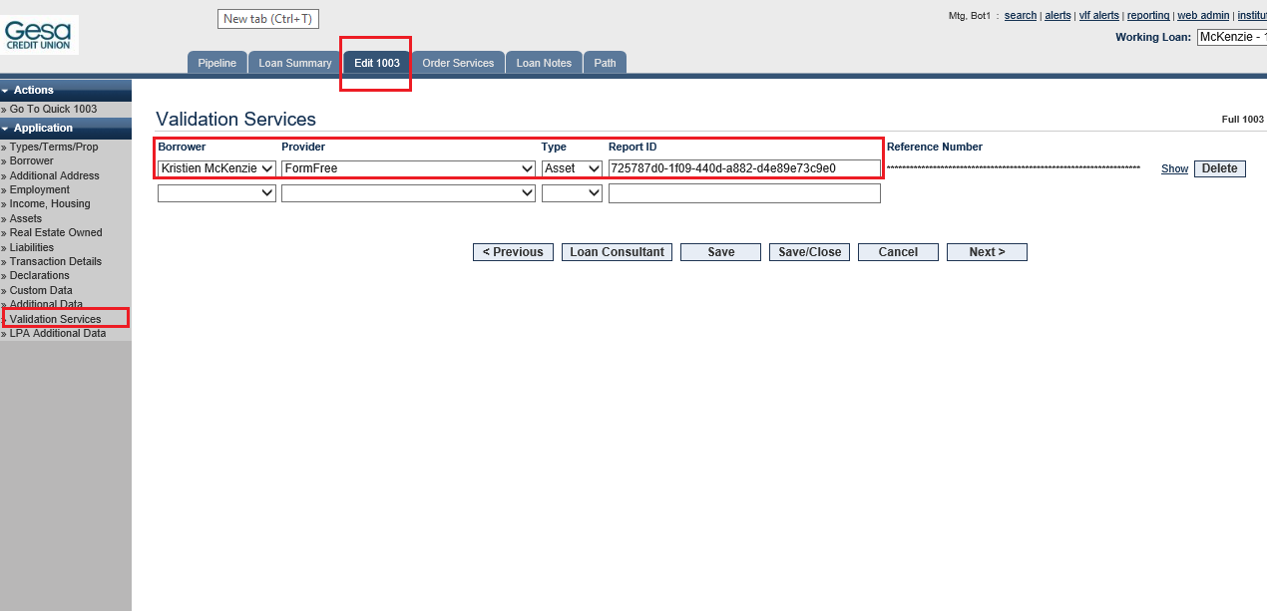

If the borrower field is already filled, then the bot checks if the borrower name is same as the one previously extracted using regex. In case the name is same, then that particular transaction is skipped.

If the borrower field is empty, then the bot fills it up with the name extracted using regex.

Provider field is always formfree and type is asset. The report id that was previously extracted is entered into the report id field.

If the applicant contains a coborrower, then those respective values are entered into the next row. Else the transaction moves onto the next applicant.

**Employment Verification Using Work Number**

**STEP 1:**

Login to cadence application using valid user credentials



**STEP 2:**

Loan Ids are passed one by one from the orchestrator queue and searched for in cadence.



**STEP 3:**

For each loan id, the bot navigates to the order services page and selects the work number – Equifax option from the drop down menu and clicks the go button

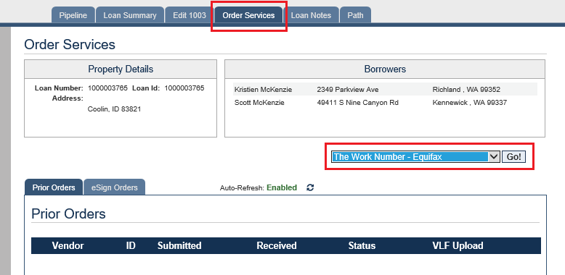

Before selecting work number – Equifax from the drop down, the bot scrapes the prior orders table and checks if it has already been uploaded before. If it has been uploaded before and the status is failure or is being uploaded for the first time, only then it uploads again.

If it has been uploaded before and the status is success, then the process skips that particular transaction.

**STEP 4:**

On the next page, the bot selects “VOE – Self Select” option from the drop down menu and clicks on continue

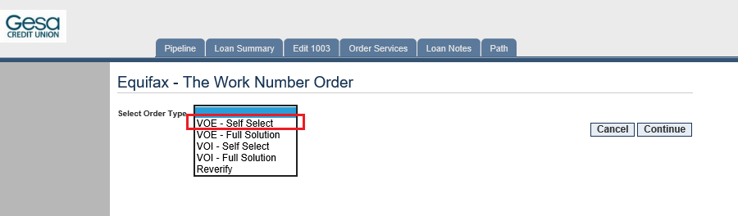

**STEP 5:**

On the next page, the bot checks the “search by SSN” box and sets the employee status as active

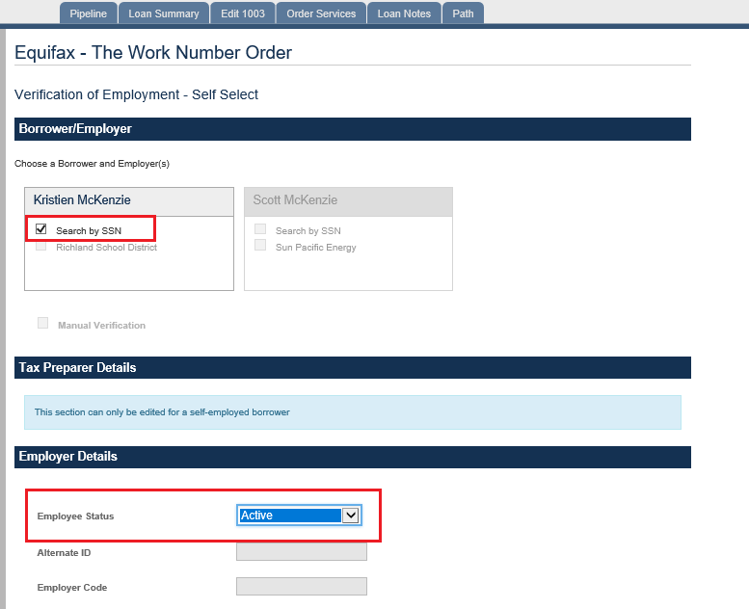

Sometimes, on clicking the search by SSN checkbox an error will occur as follows



In such situations, it is considered as business exception and the process continues with the next transaction.

**STEP 6:**

Once the processing is completed, the page navigates back to order services and waits for the status to change to success. In case it changes to failure, the process continues with the next transaction.

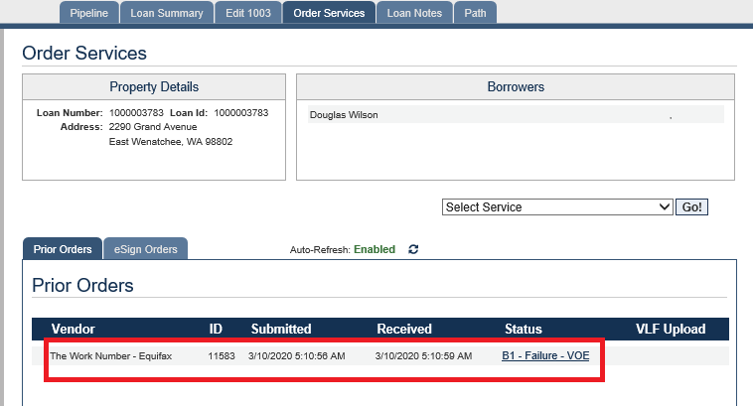

**STEP 7:**

If the status is success, then the bot clicks on the success word. A popup to download the file will come up and the bot saves it into the desired location.

**STEP 8:** Now the bot navigates to the virtual loan folder from the loan summary page and clicks on Upload PDF/TIF Files

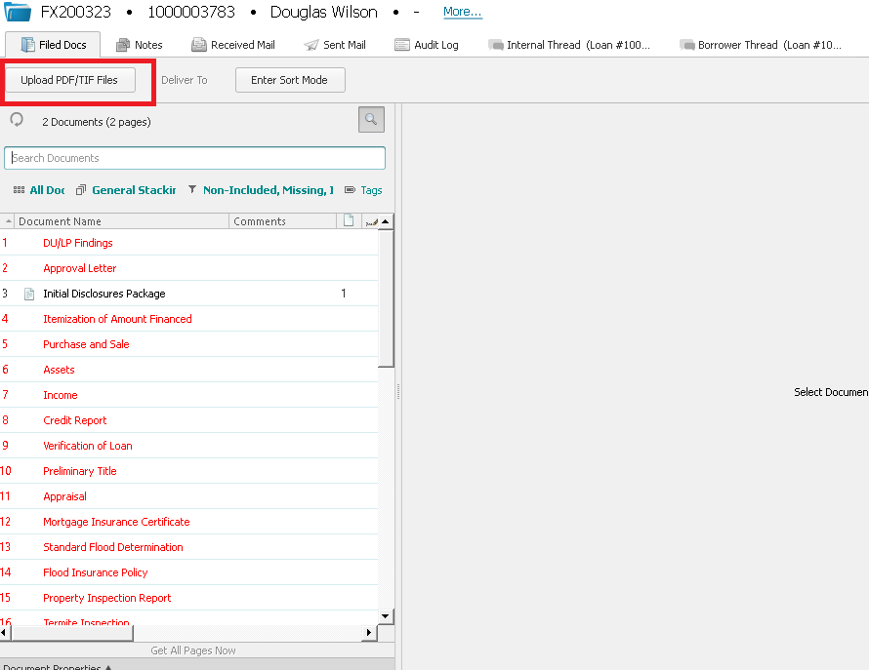

**STEP 9:**

Bot uploads the file that was previously downloaded by clicking on “Attach pdf/tif files” button and checking the “files these documents” box

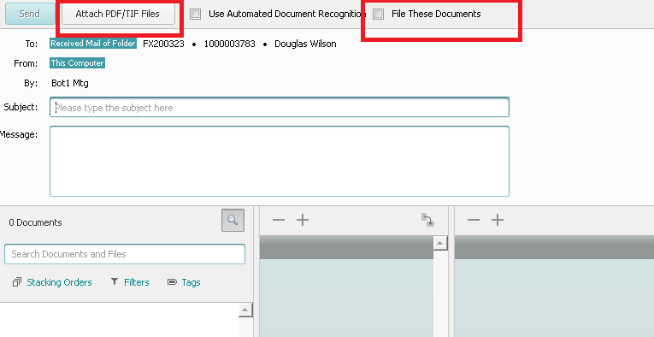

**STEP 10:**

Once the file has been uploaded successfully, it is renamed as income

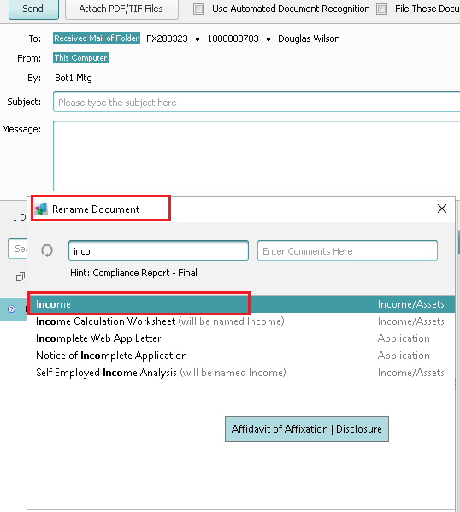

This marks the end of the process for one applicant. The same steps are followed for the rest of the applicants in the queue.

**County Map Download**

**STEP 1:**

Login to cadence application using valid user credentials



**STEP 2:**

Loan Ids are passed one by one from the orchestrator queue and searched for in cadence.



**STEP 3:**

Once the application is loaded, the bot navigates to order services page and scrapes the full address from property details

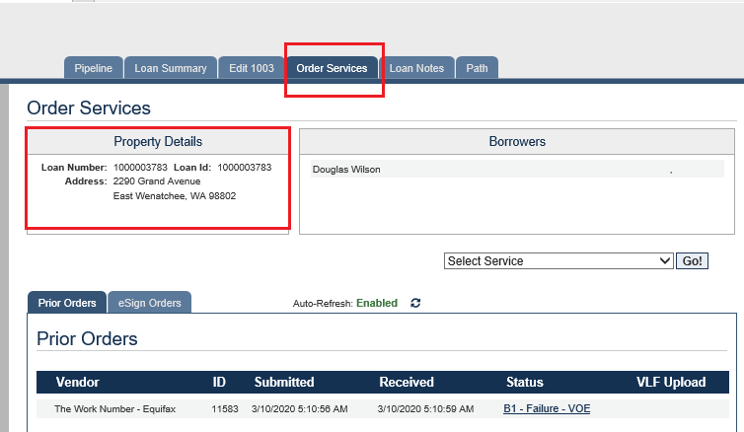

**STEP 4:**

Next the bot navigates to Edit 1003 page and scrapes “Address”, “City” and “county” from property information and purpose of loan. If the address from edit 1003 is “To be determined” or blank, then that particular transaction is considered as business exception and skipped.

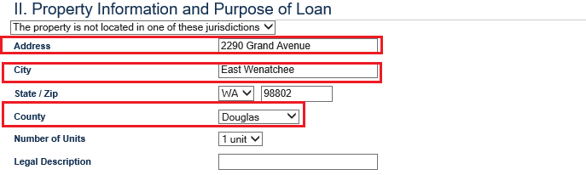

**STEP 5:**

Login to Datatree application using valid user credentials



**STEP 6:**

In the search by field, select “address” and in the street address and city/state or zip code area, enter the full address that was previously scraped from the order services page

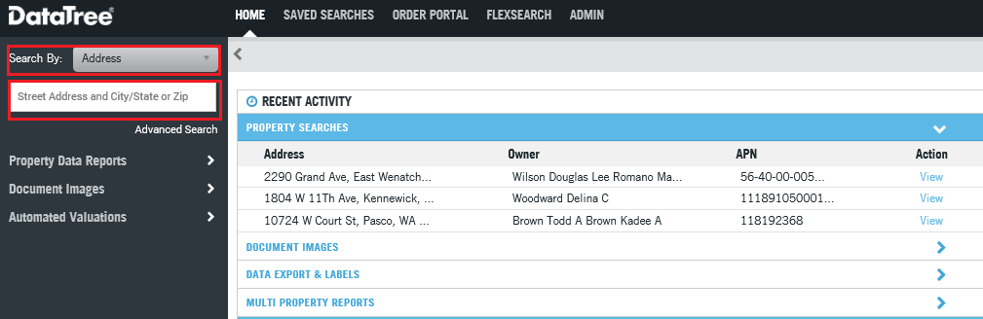

**STEP 7:**

Once the search result has loaded, under property data reports, click on property detail report and click on order

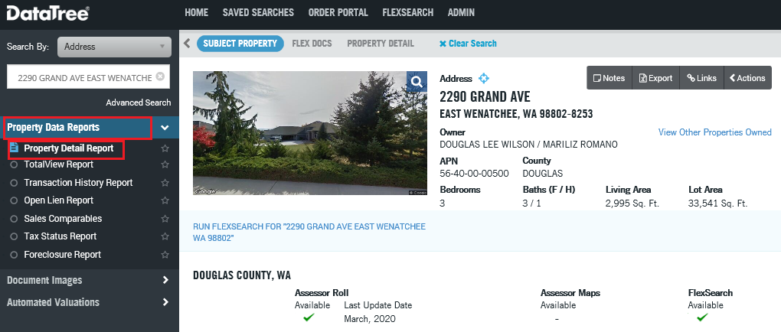

**STEP 8:**

The property report will be saved into the desired folder. The bot now navigates to the virtual loan folder through the loan summary page

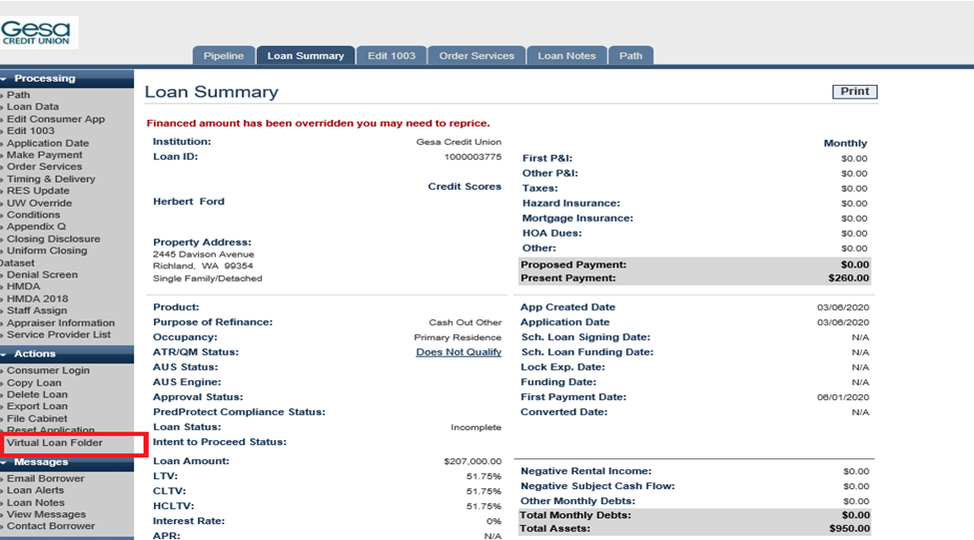

**STEP 9:**

Upload the property report that was downloaded from datatree into the virtual loan folder. Click on Upload PDF/Tif files and enter the path of the report



**STEP 10:**

Click Attach PDF/TIF files and tick the files these documents box. The file will now get uploaded into the miscellaneous folder of VLF. This marks the end of the process for one applicant

**STEP 11:**

In case after the bot enters the full address in datatree, there are multiple search results or zero search results, this will be considered as business exception and the transaction will be skipped

**Round Robin Assignment of Processors**

Processing Users are maintained in the database with the below details, they are grouped by Group Type, Team and Loan Type.

GroupType column is the role of the user, Team column is the name of the team and LoanType column is the type of the loans the user processes.

Counter column tracks the applications that are assigned to the respective user. Counter starts with 1 so the actual application assigned will be 1 less than the value shown in this table.

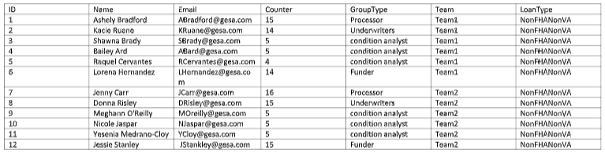

Logic Used for the round robin

**STEP 1:**

For each item from the queue, the bot navigates to edit 1003 page and determines the type of loan

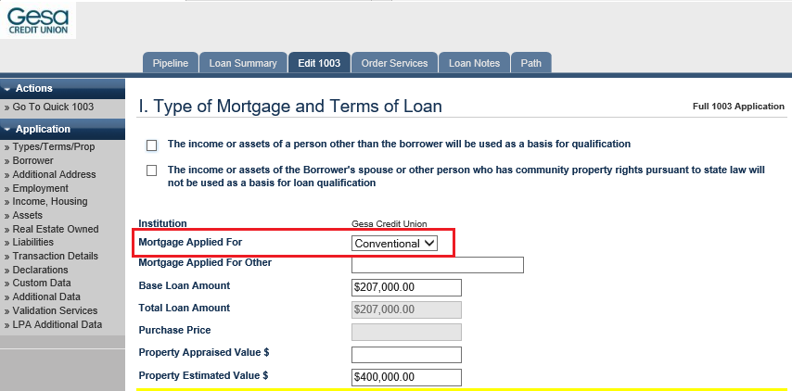

**STEP 2:**

This information is passed to the procedure to get the round robin assignment. First step in the procedure is to identify the user with the GroupType Processor with the lowest Counter value for the respective LoanType.

In the above table it would be Ashley as her counter value is 15 and Jenny’s Counter value is 16.

**STEP 3:**

Once the processor is identified, corresponding Team is also identified for further assignments. So, in this case the Team selected would be Team1.

For each of the GroupType in Team1 we identify Condition Analyst, Underwriter and Funder with the lowest counter value in the respective GroupTypes in Team1.

So below are the final selected users. 

**STEP 4:**

Once all the positions have been selected, the bot navigates to the staff assignment page on cadence

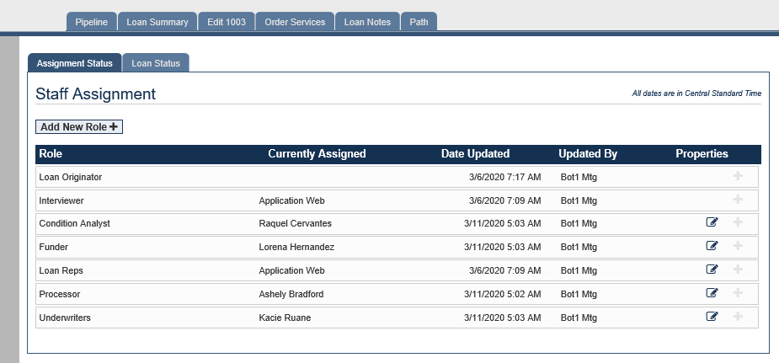

**STEP 5:**

To begin with, the bot checks if the underwriter, processor, funder and condition analyst positions are already assigned. If yes, then it is considered as a business exception and that particular transaction in skipped.

Else based on the logic from steps 1-4, the staff assignment is done. This marks the end of the process for one particular applicant.

**DISPATCHER PROCESS**

**STEP 1:**

Login to cadence application using valid credentials. After successful login the bot scrapes all the applicant details available in the pipeline page.

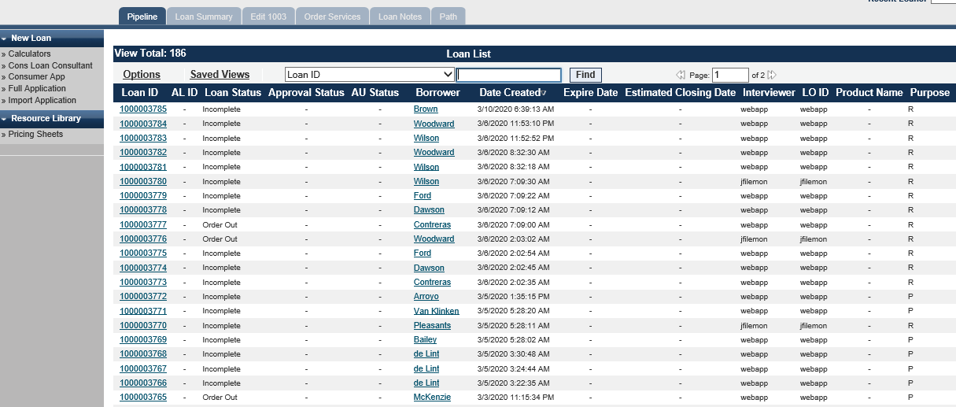

**STEP 2:**

The Bot filters out only those applications with the loan status as “Order Out” and adds it into the common queue i.e. ProcessorQueue.

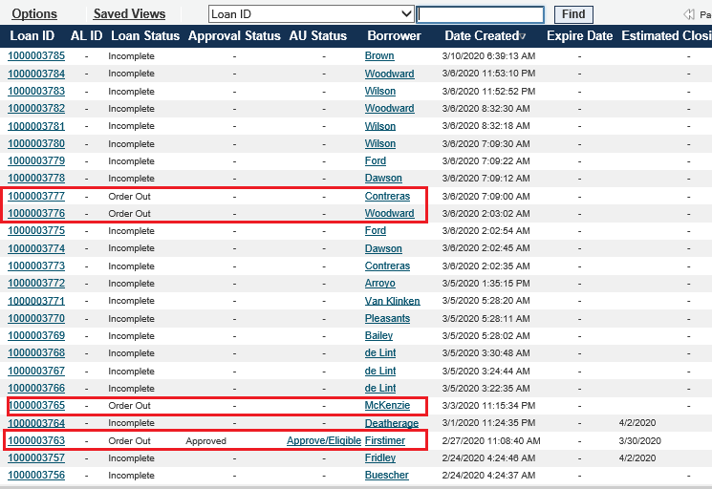

**STEP 3:**

Now for each application from the queue, the bot navigates to edit 1003 page and checks the loan type. If the Loan type is “conventional”, only then it proceeds to the next step. Else if it is VA or FHA type, then it is considered as business exception and that particular transaction is skipped.

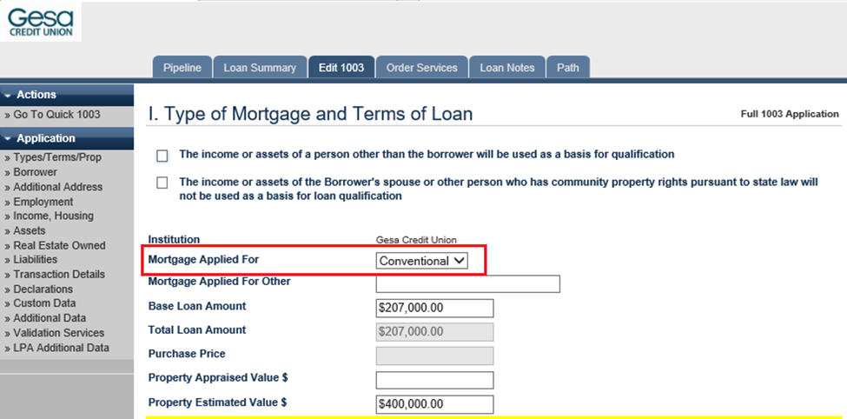

**STEP 4:**

If the Loan type is conventional, then that particular application is added to all the other queues in the orchestrator for further processing like compliance report process, application fee disclosure process, flood determination process etc. This is the end of the process for that particular application.

**COMPLICANCE REPORT PROCESS**

**Step 1:**

For each application obtained from the orchestrator queue, the bot navigates to the virtual loan folder from the loan summary page

**STEP 2:**

In the virtual loan folder, it searches for compliance report folder and checks if it already contains any documents. If the documents are already present, then it is considered as business exception and that particular transaction is skipped.

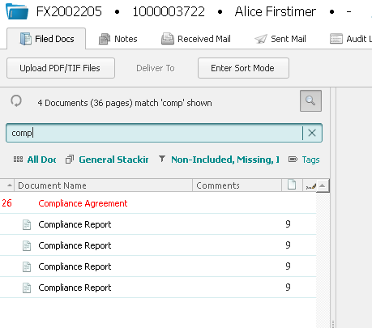

**STEP 3:**

If compliance report is not already uploaded into the VLF, then the bot navigates to order services page in cadence and selects compliance – interthinx PredProtect from the dropdown menu.

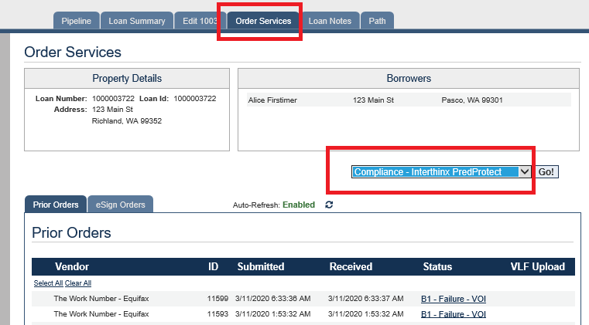

**STEP 4:**

In certain scenarios, an error occurs as follows. Such cases are again considered as a business exception and the transaction is skipped.

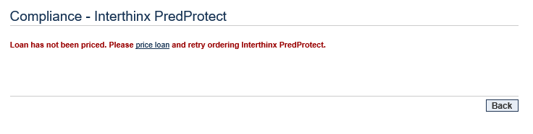

**STEP 5:**

If the status of the order changes to success/pass, then the bot clicks on the “success/pass” and a new page containing the report gets loaded. Next, it click on “view most recent report”.

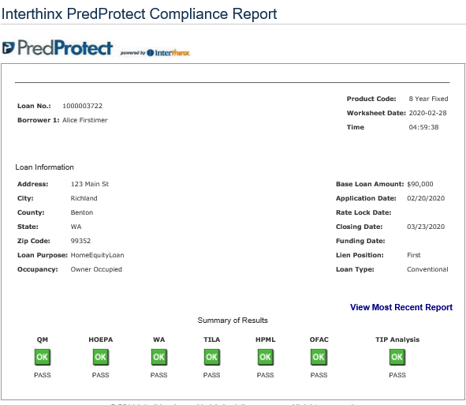

**STEP 6:**

The scrapes the summary table from the report and logs the same in the database. For e.g.: Qm, Hoepa,hmpl etc.

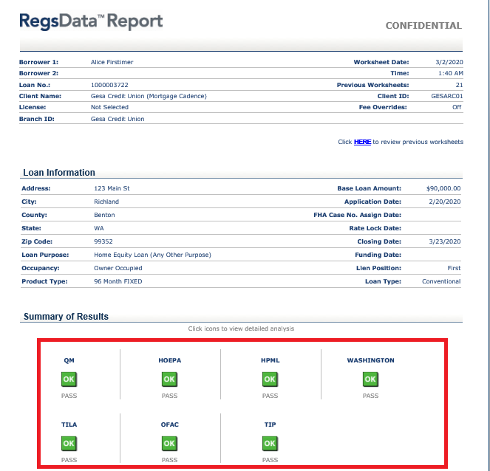

**STEP 7:**

Click on print worksheet and then again print on the next window and save the files into the desired location. Microsoft print to PDF should be manually set as the default printer before starting the whole process.

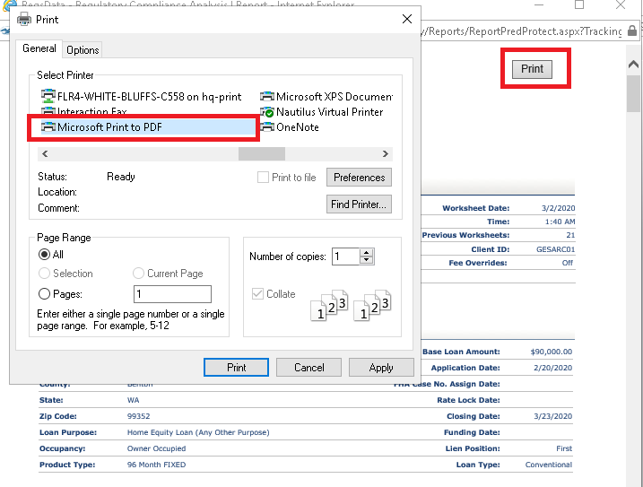

**STEP 8:**

Finally, the bot navigates back to the virtual loan folder and uploads the previously downloaded file into the compliance report folder

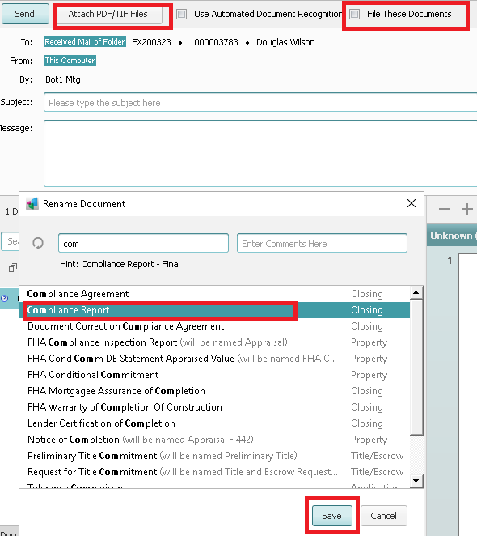

**STANDARD FLOOD DETERMINATION**

**Step 1:**

For each application obtained from the orchestrator queue, the bot navigates to the virtual loan folder from the loan summary page

**STEP 2:**

In the virtual loan folder, it searches for flood report folder and checks if it already contains any documents. If the documents are already present, then it is considered as business exception and that particular transaction is skipped.

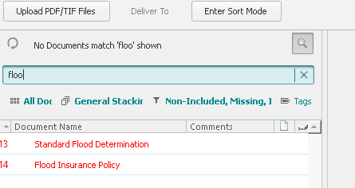

**STEP 3:**

If flood report is not already uploaded into the VLF, then the bot navigates to order services page in cadence and selects flood-FZDS from the dropdown menu.

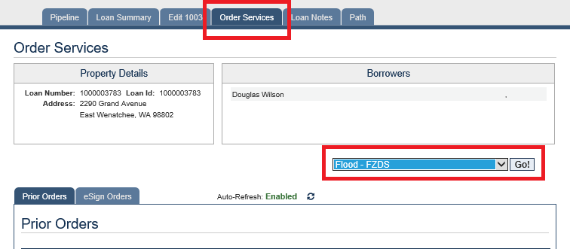

**STEP 4:**

On the next page, the product to be chosen is “Life Of Loan Cert With Census Tract” and submit button is clicked.

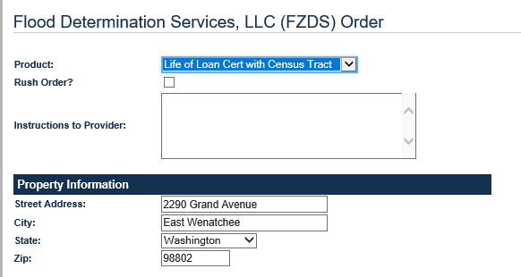

**STEP 5:**

If the status of the submitted order is success/pass, then the “success/pass” is clicked. On the next page, Life of loan cert with census tract is clicked

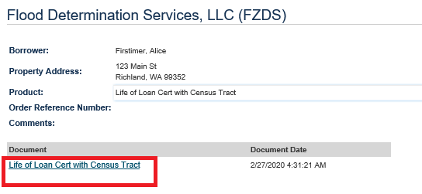

**STEP 6:**

On clicking the link, a pop up request to download the file will appear. Save the file into the desired location



**STEP 7:**

This downloaded file is now uploaded into ABBY process, to check if the Yes/No box is checked. If Yes is ticked, the same downloaded pdf is sent as an attachment in the email to the borrower.

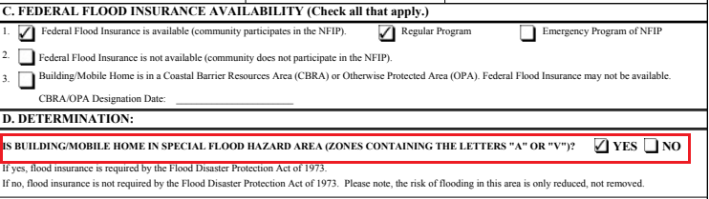

**STEP 8:**

As a last step, the bot navigates back to the virtual loan folder and uploads the downloaded pdf into standard flood determination folder.

